**CALCULATIONS FOR LIFT PRESSURE**

Weight Force in Newtons: F=m x g = 2kg x 9.81 m/s2

**F≈ 19,62 N**

* Force acting under the surface:  
  Hole: 45mm x 15mm, Surface: 292mm x 415mm  
  So,   
   A≈ (0.292 x 0.415) – (0.045 x 0.015)

**A≈ 0.120505m2**

* Pressure needed in order to lift the hovercraft is:  
    
   **P**≈ $\frac{F}{A}$ ≈ $\frac{19.62 }{0.120505 }$ ≈ **162.81 Pa** or (N/m2)  
  A centrifugal fan will be used for the lift.  
   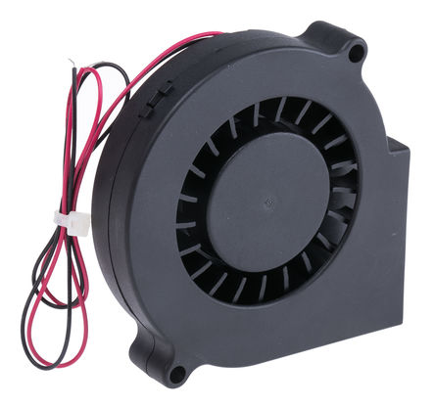
* Dynamic Pressure:  
   Q= ½ x ρ x v2 where: ρ= Air density (Kg/m3)  
   v=Fluid velocity (m/s)

We know: ρ= 1.225 kg/m3 & v≈2.29 m/s. We know the velocity from the graph provided from the company’s data sheet. In order to produce high pressure, the velocity has to be under 2.3 m/s. Therefore, Q= ½ x 1.225 x (2.29)2

**Q= 3.21 Pa**

* Total Pressure produced from the centrifugal fan:  
   Pt= PD + PS   
   **Pt= 176.94 Pa at 2.29 m/s air flow**.  
    
   PS= Static Pressure (at 2.29m/s) = 173.73 Pa

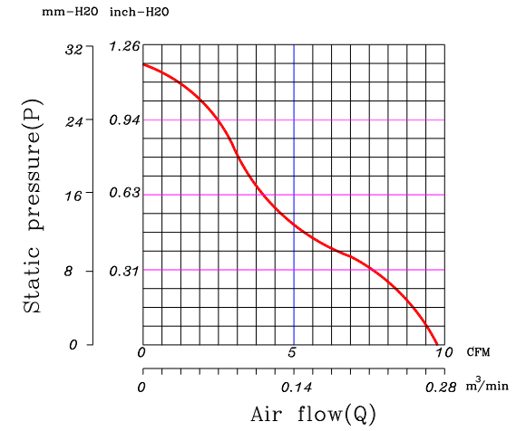

|  |  |  |
| --- | --- | --- |
| *Budget* | | |
| Product | **Number of Products** | **Price (£)** |
| Centrifugal Fan | 1 | 10.60 |
| Blades | 2 | 6.80 |
| Craft Foam Blue | 1 | 12 |
| Motor | 2 | 8 |
| 6 Channel Radio | 1 | 30 |
| Battery-Charger | 1 | 60 |
| Electronic Speed Controller (ESC) | 4 | 16 |
| Other Material | _ | 30 |
| Servo | 1 | 6.67 |
| Total | 13 | 180.07 |